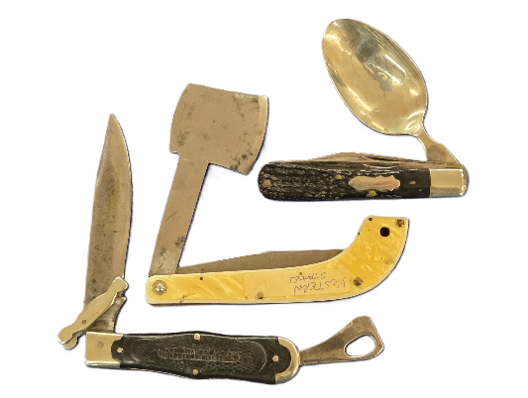
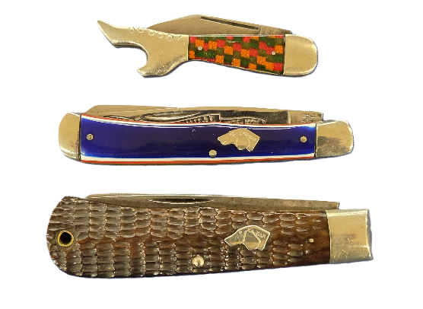
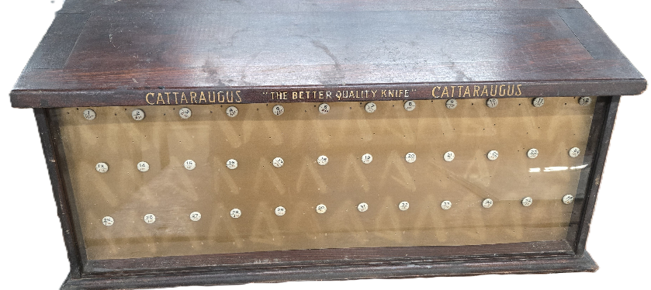
SPECTACULAR KNIFE AUCTION
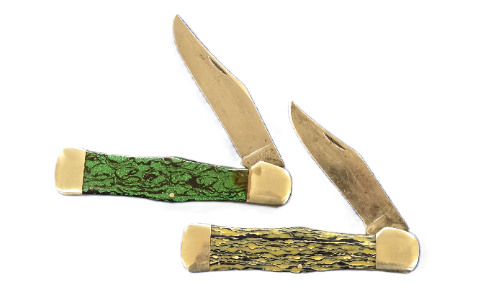
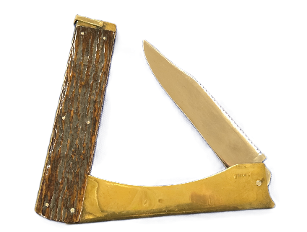
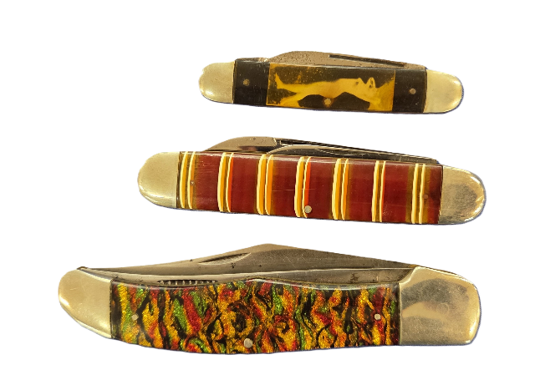
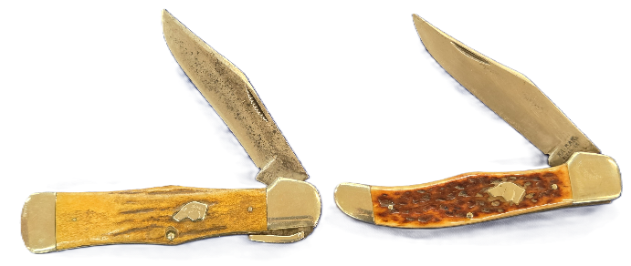
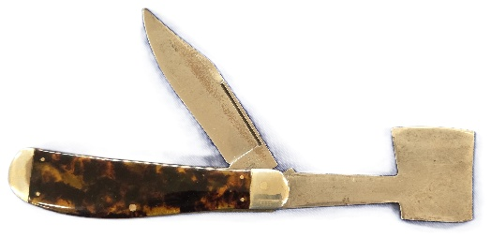
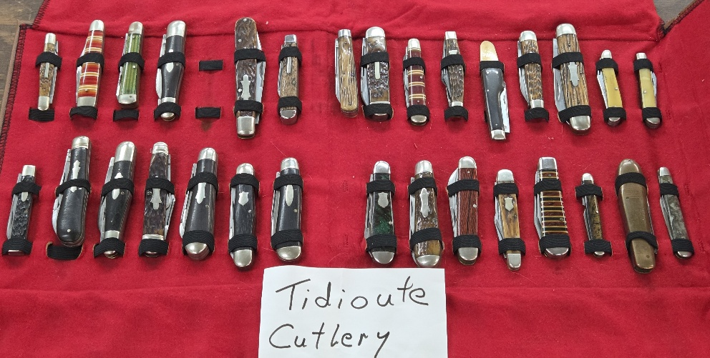
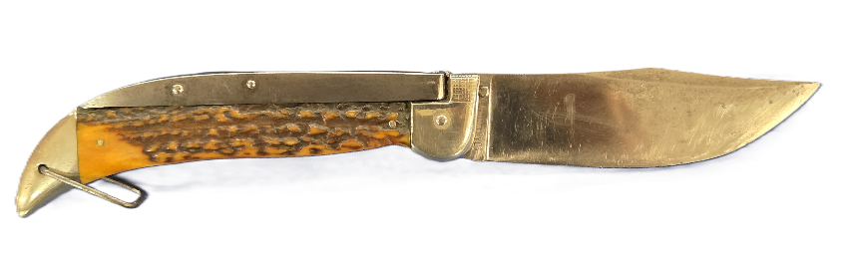
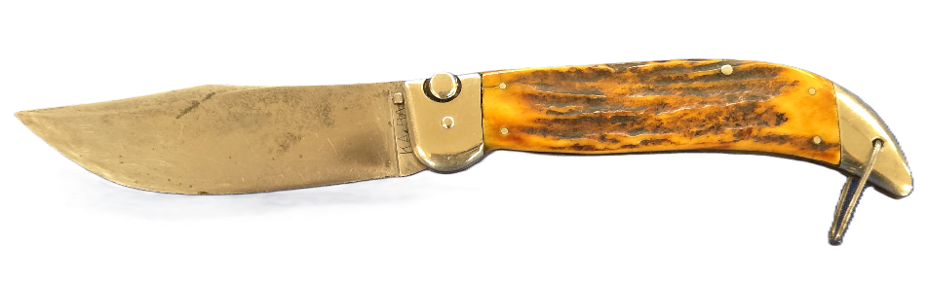
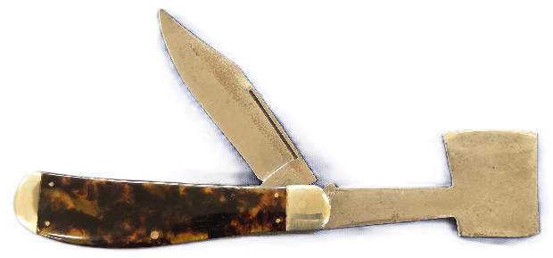
716/485-6164
COREYBROWNAUCTION.COM
FROM THE ESTATE OF LESTER WEAVER OF FRYBURG PA
**400 PLUS KNIVES INCLUDING OVER 200 TIDIOUTE KNIVES - UNTOUCHED FOR OVER 20 YEARS**
SATURDAY AUGUST 8 @ 10 AM
19 RAILROAD AVE FREWSBURG NY 14738
AN EXCEPTIONAL COLLECTION OF TIDIOUTE, JEAN CASE, KABAR, CASE, BARLOW, MOTHER OF PEARL, ELEHANT TOE, INCLUDING NEW OLD STOCK KNIVES, AND MORE!
LIVE AND ONLINE BIDDING!

